Lab 9

Ex 1.

1. beers = c(5,2,9,8,3,7,3,5,3,5)
bal = c(0.1,0.03,0.19,0.12,0.04,0.095,0.07,0.06,0.02,0.05)
res = lm(bal~beers)
plot(bal~beers)
abline(res)
pred = predict(res,int="prediction")

lines(beers,pred[,2], lty=2)
lines(beers,pred[,3], lty=2)
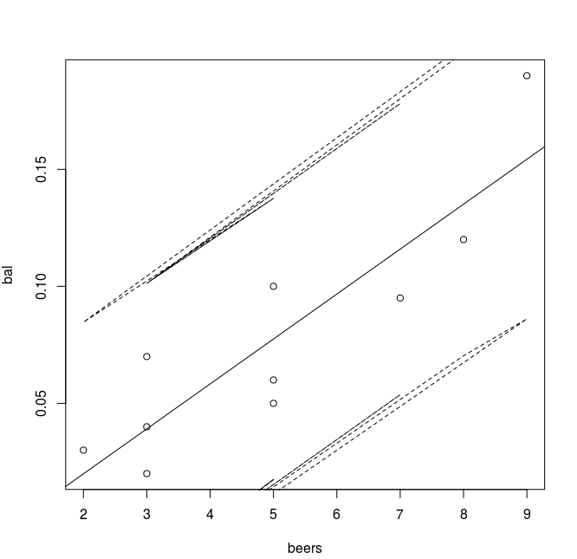

2. summary(res)

Call:
lm(formula = bal ~ beers)

Residuals:
Min 1Q Median 3Q Max
-0.0275 -0.0187 -0.0071 0.0194 0.0357

Coefficients:
Estimate Std. Error t value Pr(>|t|)
(Intercept) -0.018500 0.019230 -0.962 0.364200
beers 0.019200 0.003511 5.469 0.000595 ***
---
Signif. codes: 0 ‘***’ 0.001 ‘**’ 0.01 ‘*’ 0.05 ‘.’ 0.1 ‘ ’ 1

Residual standard error: 0.02483 on 8 degrees of freedom
Multiple R-squared: 0.789, Adjusted R-squared: 0.7626
F-statistic: 29.91 on 1 and 8 DF, p-value: 0.0005953
betahat1 = -0.019200
SE = 0.003511
tstar = qt(1-0.05/2, df = 2)
c(betahat1 - tstar*SE, betahat1 + tstar*SE)

Output:
-0.034306614 -0.004093386

Ex. 2

1. attach(deflection)
res = lm(Deflection~Load)

2. plot(Deflection~Load)

3. par(mfrow=c(2,2))
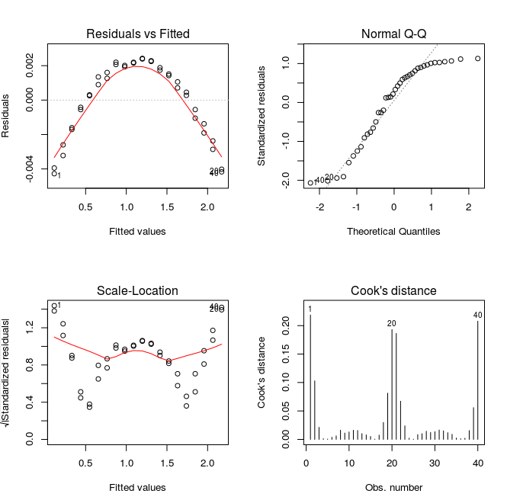
plot(res, which = c(1:4))

4.

